Lost at Sea Homework Name: _____________________________
ISP203a: Global Change; Michigan State University
Created: Steven Callahan, University of Arizona
Modified: Dr. Ryan G. Vannier, 2019 Student ID#: _____________________________
Lost at Sea
Background:

After graduating, you and two of your classmates decide to embark on a sailing voyage. Being novices at long-distance sailing, you and your friends decide to tackle something that appears relatively simple. You decide that a round-trip across the Atlantic, starting in North America, would NOT be a bad idea. You decide to leave from North Carolina, where the old boat you bought is located, and travel across to England, then south from there all the way down to Morocco, then back across the Atlantic. You also decide to prepare by digging up your old ISP 203a notes and a map of ocean currents to help you out….

- How do you plan your route there and back, so that the prevailing ocean currents provide the most help? Which currents are these? Draw them and label them on the map on the last page of this handout.

3 POINTS
List of currents should include: Gulf Stream, North Atlantic Drift (accept one or the other, or both), Canary Current, and North Equatorial Current.

1 pt total for list of currents, 1 pt total for drawing on back page.

- You know that currents are driven by winds. What are the two major winds that drive the currents you will use in part 1?

2 POINT
Should be NE Trade Winds, and Westerlies

Getting across to England is a breeze – you can’t believe how easy the trip was, and how quickly it all went by. Now you are ready to head back. You know the trip home will take longer…

You are back at sea, just entering the warmer climates to the south, when disaster strikes. Off the Canary
Islands (on your map), your boat capsizes in a storm. Before she sinks, you have just enough time to grab the emergency kit and jump into the inflatable lifeboat. Whew! But…now what??? The current is flowing westward; try as you might, you can’t make the boat go east as you have no sail. So, you’re off across the Atlantic again, although not exactly as you’d planned. This WILL be educational!
A few days later…you’ve been drifting rapidly, and you realize that you no longer know exactly where you are. You need to figure this out so that you can plan your food and water supplies, and so that you can know if you are likely to see land anytime soon. You’ll have to rely on those rusty navigational skills.

- The Sun is directly overhead and your watch says that it’s June 21. What’s your approximate latitude? How do you know?

2 POINT

23.5 degrees N latitude – because on June 21 it is summer solstice when the planet is leaning towards the sun (axial tilt being 23.5 degrees) – so the sun’s direct rays (or the sun is directly overhead) on June 21 at 23.5 degrees north.

- Now calculate your longitude. Your watch is still on London time, but you notice that when the Sun is directly overhead at your current position, your watch reads 1:30 p.m. You realize you can calculate your longitude. What is it?
2 POINTS

For every 1 hours the Earth spins 15 degrees. So if it is 1200 Greenwich Mean Time (London) and its 1:30 where we are… 1 hr = 15 degrees
+ ½ hr = 7.5 degrees
22.5 degrees West Longitude

- From your map, you can see now that you are north of a group of islands at about 15⁰N, 25⁰W. If you miss these islands, your map of Atlantic Ocean currents suggests you might have a long trip ahead. What’s the name of the island group?

1 POINT
Canary Islands

With a stiff breeze from the NE, you drift for another 2 weeks, but then the wind dies back. You start to experience frequent rain showers that help you capture fresh water. You seem to be moving west, although there’s no strong wind. Oh @#%&!!, did you miss your islands? Ummm…yeah…

- What current is taking you west, and what’s the name given to the region (or wind system) you have encountered?

2 POINT
North Equatorial Current or the NE Trade winds

Your map shows several islands further south. What are your chances of reaching them, given what you know about winds and currents? Explain.

1 POINT
Cape Verde Islands – little chance of reaching them because the winds and currents are taking you west, not south.

- You recall a real-life story of a similar situation - one man spent 76 days adrift at sea before drifting ashore. He survived (but was very skinny by the end). You’ve been at sea 21 days and you guess you are 4000 km from land and traveling 1 m/sec. How much longer will you be drifting? Be sure to show your work.

3 POINTS

4,000 km = 4,000,000 meters. At a rate of m/sec = 4,000,000 seconds

4,000,000 seconds = 46.29 days – but be sure they show their work!

- Eventually you make it safely back to land in the Caribbean where you take a well-deserved break. While recuperating on the beach, a reporter asks to hear about your epic journey for a news story.

Briefly summarize how your journey proceeded for the reporter and explain how and why it deviated from your planned route. Also, include anything you would do differently if you made this journey again and any other materials you’d bring with you.

4 POINTS –1 POINT IF JUST PARTIAL SENTENCE OR A COUPLE OF WORDS, TWO OR THREE IF THEY SHOWED SOME EFFORT, ALL FOUR POINTS IF A COUPLE SENTENCES AND PUT SOME EFFORT INTO THE ANSWER.

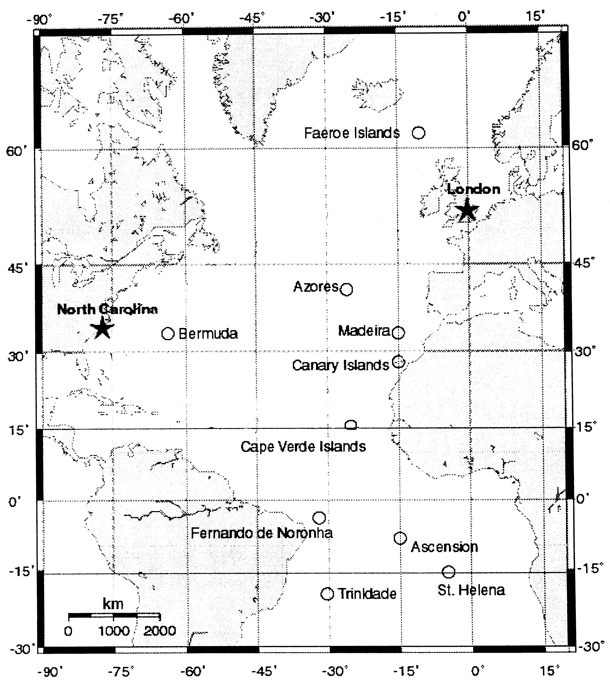

Modified from an exercise developed by oceanography faculty at the University of Arizona and based on the book Adrift: Seventy-six Days Lost at Sea by Steven Callahan.

