There are two extraordinary and detailed long term records of the Earth’s climate:

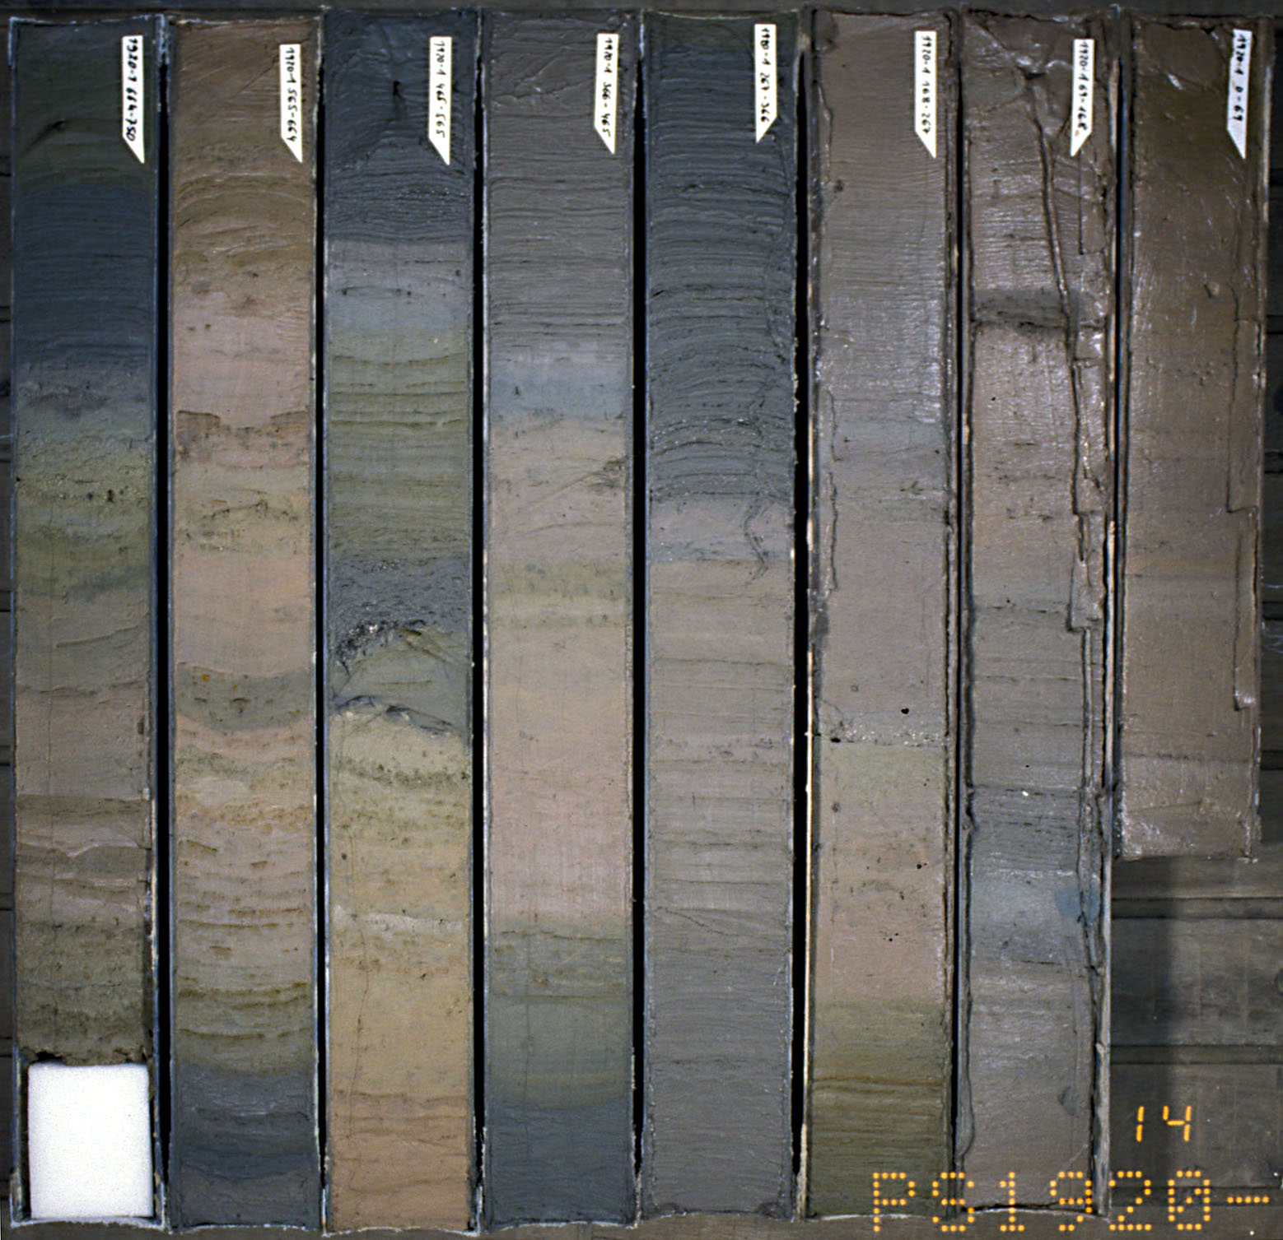
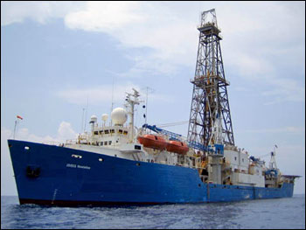
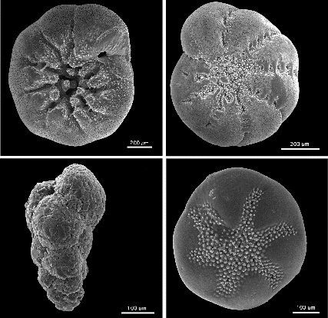
Deep Sea Cores: Sediment accumulates on the ocean’s floors through time. Cores of ocean sediments throughout the world have yielded considerable information about the earth’s past climate over the last 2.7 million years. Chemical analysis of foraminifera (unicellular animals with carbonate shells) provides a record of sea surface temperature and ice volume, and sediment analysis records changes in the amount material eroded from the earth’s surface and frequency of icebergs through time. Also, variation in species of forams in a core reflects changes in the oceans salinity and currents.
Figure 1
Deep sea cores recovered via ocean going drill rigs, like the Poides Resolutin, record changes in oceanic conditions over time.
One such change is in the number of foraminifera.
The lighter colored bands represent times of deposition when forams were very abundant, while darker bands are times when fewer forams lived off the coast of Greenland.
Like all animals, different foraminifera have specific environmental requirements, some requiring colder, less saline water, while others prefer saltier, warm water.
Figure 2
The global benthic δO¹⁸ record from 57 deep sea cores. The greater the δO¹⁸ values the more water was locked in glaciers, and thus, the colder the earth’s climate.

Note the “saw-tooth” pattern in which climate became gradually colder and then rapidly warmed several times over the last 2.7 million years.
Ice Cores: Chemical analysis of ice cores from Greenland and Antarctica provide long records of ice sheet growth, precipitation, air temperature, and insolation. Sediment analysis (dust) provides long records of major episodes of volcanic activity, provides material for dating ice-core layers, and document changes in wind patterns.

Oxygen isotopes within the carbonate shells of forams in deep sea cores and air bubbles trapped in glacial ice provide the most important record of warm and cold periods on Earth.
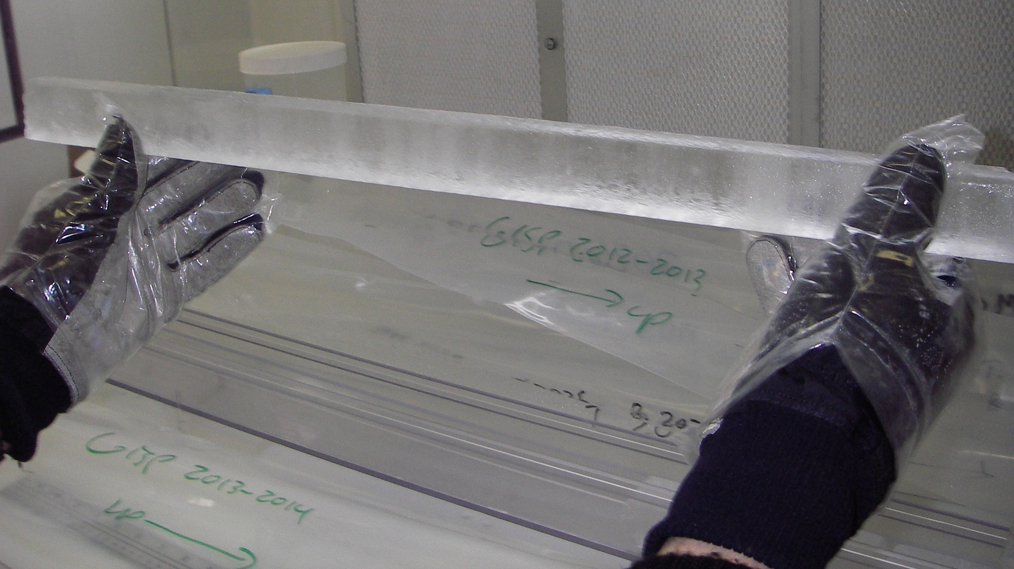
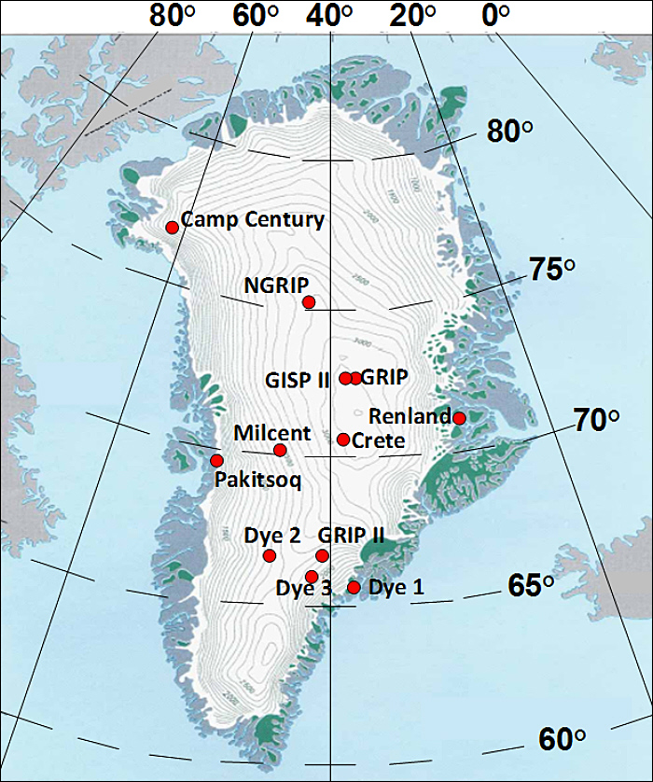
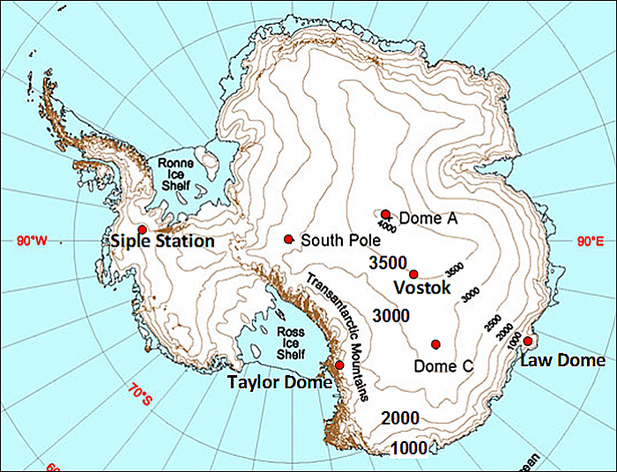
Figure 3
A section of a Greenland ice core and locations of some important ice cores from Greenland and Antarctica.

Oxygen Isotopes
There are two forms of oxygen, a heavier ¹⁸O isotope and a lighter ¹⁶O isotope. The ratio of these isotopes (the ¹⁸O/¹⁶O ratio) in a core tells us about cold and warm periods in the earth’s climate because the lighter ¹⁶O molecules evaporate slightly easier. Thus, precipitation has more ¹⁶O than in the ocean. When this precipitation falls in the form of rain it eventually mixes with ocean water keeping the ratio in balance.

- When precipitation accumulates in ice sheets, however, the bubbles of air contain more ¹⁶O causing the amount of ¹⁶O in oceans to be depleted.
- Likewise uptake of oxygen by forams for their calcium carbonate (CaCO₃) shells records the ¹⁸O/¹⁶O
ratio in the ocean. During warm periods the ratio is balanced, but when ¹⁶O becomes trapped in ice, the foram shells have a higher concentration of the heavier ¹⁸O while ice bubbles contain greater concentrations of ¹⁶O.

Fluctuations in number of heavy and light isotopes of other chemicals also reflect ice-sheet size. Among these is hydrogen. The normal hydrogen molecule ¹H is lighter than the heavier molecule ²H, called deuterium.
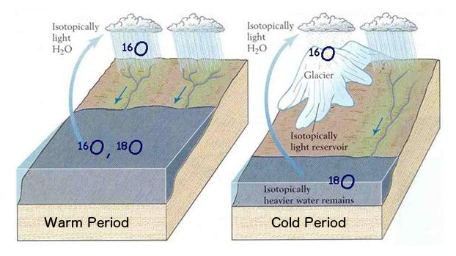
Figure 4

Because ¹⁶O is lighter than ¹⁸O, it evaporates more readily, and precipitation is enriched in ¹⁶O. During warm periods (interglacial periods) when precipitation falls mainly as rain and ice sheets are melting, ¹⁶O quickly mixes with ocean water and the ¹⁸O levels remain only slightly higher than those of ¹⁶O.

If ¹⁶O becomes trapped on land, however, as occurs when ice sheets form and grow (glacial periods), the amount of ¹⁸O in the ocean increases relative to the amount of ¹⁸O. Air trapped in the ice during these cold periods is enriched in lighter ¹⁶O. important ice cores from Greenland and Antarctica.

QUESTIONS:
Helpful Hint: Very carefully measure the ages asked for in the questions below. It may help to use a straight edge to identify dates.
Express all answers as years before present (or ybp).
- What important organism do marine paleontologists use to analyze deep-sea cores and document past climate change? Give two examples of how this organism reveals information about the past.
Foraminifera (Forams)
- Variations of species of these organisms allow scientists to reconstruct past ocean currents, temperature, pH, etc.
- The shells of forams are made of CaCO3 – which can be used for oxygen isotopes to tell planetary temperatures (ice age or interglacial period).

- Observe the chemical signature (¹⁸O record in Fig. 2 on the first page) of deep-sea cores. Has global climate remained the same for the last 2.7 million years? Describe how it has changed.

No, climate has shifted from periods much colder than now (ice ages) to temperatures around our current temperature. It has done so many times over the last 2.7 million years.

- Are the changes more or less extreme before 1.0 million years? Less Extreme before 1.0 mya

- At what times in the past were temperatures as warm as or warmer than the present? (Hint: The ¹⁸O record ends at the present at the top of the Fig. 2.)

Example: 125,000 years ago, 320,000 years ago, 400,000 years ago,
- Is there a pattern in the curve showing the build-up and decline of ice sheets? Which took longer ice-sheet growth or decline? Can you think of some reasons why this might be the case?
Yes, ice sheets were slow to build up but disappeared very quickly. This is due to positive feedback loops associated with the ice. As the ice sheets grew, so does the albedo feedback. More ice = more of the planet is reflecting light back into space.

- Identify three times (in years before present) when oceans were the most highly enriched in ¹⁸O. What was the global climate at these times?
This is when the isotope line is going all the way to the left (or the 18O values are close to 5).
Approximately 140,000 years ago, 430,000 years ago, 625,000 years ago.

- Identify three times (in years before present) isotope ¹⁸O levels in the oceans were the most depleted.
This is when the isotope line is going all the way to the right (or the 18O values are close to 3.2).
Approximately 125,000 years ago, 320,000 years ago, 400,000 years ago
- What ¹⁸O values indicate ice sheets were at their largest?
A value of close to 5
- What ¹⁸O values indicate ice sheets were at their smallest extent?
A value close to 3.2
- How many times does this graph indicate the Earth’s climate was coldest with its largest ice sheets (otherwise stated: how many times does the isotope record reach 5 per mille)?
4 times

- How many times does this graph indicate the Earth’s climate was warm like the present?
4-5 times

- Has the Earth’s climate over the last 600,000 years been dominated by warm periods like the present, or cold periods when ice-sheets covered much of the earth?

Way more often the planet has been colder than now. Maybe not as cold as the maximum of an ice age, but the planet is almost always somewhere between as warm as now and as cold as the last ice age maximum.

