420,000 years of ice core data from Vostok, Antarctica research station
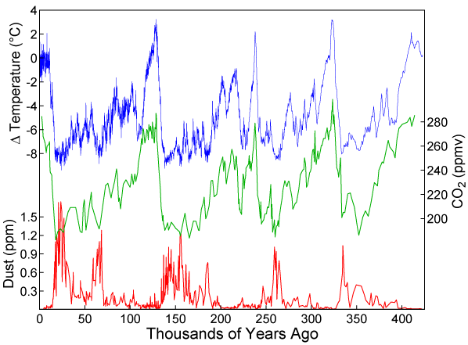

Why use ice cores?
Ice sheets have one particularly special property. They allow us to go back in time and to sample accumulation, air temperature and air chemistry from another time. Ice core records allow us to generate continuous reconstructions of past climate, going back at least 800,000 years. By looking at past concentrations of greenhouse gasses in layers in ice cores, scientists can calculate how modern amounts of carbon dioxide and methane compare to those of the past, and, essentially, compare past concentrations of greenhouse gasses to temperature.
Ice coring has been around since the 1950s. Ice cores have been drilled in ice sheets worldwide, but notably in Greenland and Antarctica. High rates of snow accumulation provide excellent time resolution, and bubbles in the ice core preserve actual samples of the world’s ancient atmosphere. Through analysis of ice cores, scientists learn about glacial-interglacial cycles, changing atmospheric carbon dioxide levels and climate stability over the last 10,000 years. Many ice cores have been drilled in Antarctica.
NOTE: The answers to the following questions are not obvious, take some coaching and will be discussed in the lecture portion of the class.

Examine the patterns on the previous page of Temperature, CO₂, and Dust….
- How does the patterns that relate temperature, dust and CO₂ change in relation to one another? Why?

- Why are there regular variations in atmospheric temperature in the absence of human activity? Which of these is the largest driving factor of natural climate change?

Largest driver of climate over the last 800,000 years or so – Milankovitch cycles, in particular the 100,000-year eccentricity one.
Other drivers include volcanic events, bolide impacts (rare), plate tectonics and ocean currents (often one goes with the other), and changes in solar output both in long and short term cycles.

- Describe one positive AND one negative feedback mechanism and how it works.

Could be any of those we covered in class…

- From class: how has the emergence of agriculture affected the overall CO₂ balance of the atmosphere?

Recall that deforestation typically occurs before smaller plants are grown for food. This is a misconception actually shared by many that agriculture reduces atmospheric CO2. Considering the CO2 consumption of an old growth forest, a corn plant does little in the way of CO2 removal.

